

Outreach GDS Toolkit
Installation and User Guide

Toplevel Computing September 2014
Copyright ©2014 Toplevel Software Limited
Contents
Installing the GDS toolkit 3
Pre-requisites 3
Installation 3
Configuring a form to use the toolkit 5
General form settings 5
Form code 6
Declarations 6
Event handlers 7
Utilising GDS toolkit features 8
Buttons 8
Help Text 10
Indented Headings 13

Installing the GDS toolkit

Pre-requisites
Before installing the GDS Toolkit, you will need to have a copy of Outreach Server and Outreach e-Form Designer installed on your server, as well as all associated pre-requisites. For further details, please see the Outreach Server Installation and Configuration Guide.

Installation
- Copy all files from the Static directory of the GDS Toolkit release into your Outreach Static directory (this should be located at C:\Program Files (x86)\OfficeForms\Server\Template\VirtualForm\Static).
- Copy OutreachGDSCustomStrings.htm from the Custom directory of the GDS Toolkit release into your Outreach Custom directory (this should be located at C:\Program Files (x86)\OfficeForms\Server\Template\VirtualForm\Custom).
- Copy OutreachGDS_repo.ofcodemodule from the OFServerForms directory of the GDS Toolkit release into your Outreach Active Forms directory (this should be located at C:\OFServerForms).
- Copy OutreachGDS.theme.xml from the Themes directory of the GDS Toolkit release into your Outreach Themes directory (this should be located at C:\OFServerWorking\Themes).
- Start (or restart) your Outreach server:
- Press Windows Key + R to open the Run prompt. Type in services.msc and click OK.
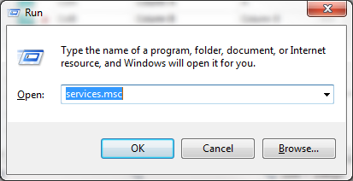
- In the Services window, scroll down until you find the OfficeForms Server service.
- Click the OfficeForms Server service and select either Start or Restart on the left sidebar.
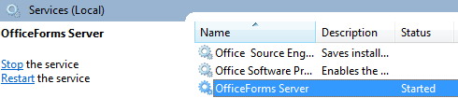

Configuring a form to use the toolkit

General form settings
- Open a new or existing form in Outreach e-Form Designer and go to Form Properties by double clicking the form icon in the top left of the field list.
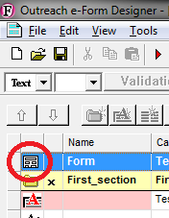
- In the General tab, under Appearance; Theme should be selected for Use. Change the Theme Name to OutreachGDS.
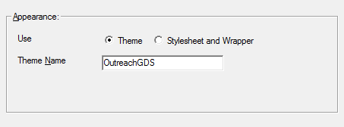

Form code
Open the Outreach Code Editor by navigating to Edit > Edit Form Code in the main menu. If you cannot find this option in the menu, go to Tools > Options and change the User Level to Developer.
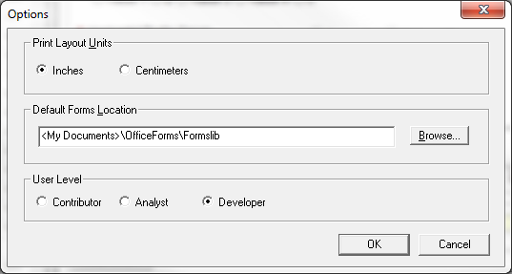

Declarations
Click on Declarations in the left sidebar:
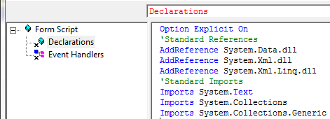

If the code below is not currently in Declarations, add it in:
Option Explicit On
'Standard References
AddReference System.Data.dll
AddReference System.Xml.dll
AddReference System.Xml.Linq.dll
'Standard Imports
Imports System.Text
Imports System.Collections
Imports System.Collections.Generic

Add the following lines to Declarations in the main window of the code editor:
Private Repo As Object
Dim ComponentCaptions As New Dictionary(Of String, String)

Event handlers
If they aren’t already displayed in your code editor, add the following event handlers:
- OnFirstLoadZCForm
- OnNewZCForm
- OnPresentSection
To do this, click the page icon above the main code window, choose Event Handler under Function Type and click OK.
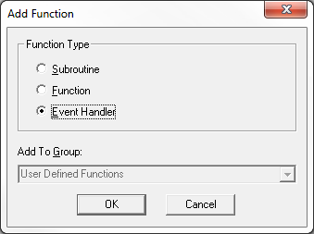
Choose the appropriate event handler and click OK, repeat until all event handlers have been added.
- Add the following code to OnFirstLoadZCForm:
If Not Outreach.CodeModuleLoad(Repo, "OutreachGDS_repo.ofcodemodule") Then
Form.ShowSystemError("Error", "Failed to load repo shared code module","","MEDIUM")
Form.EndModal("CANCEL")
Return
End If

ComponentCaptions = Repo.CaptionClone()

- Add the following line to OnNewZCForm:
Repo.Init()

Utilising GDS toolkit features

Buttons
GDS Outreach forms can have three button types:
- Primary call-to-action
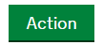
- Secondary actions
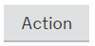
- Secondary toolbar & table actions
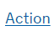
By default, a form configured to use the GDS toolkit will have a Continue button (equivalent to the Next button in default Outreach forms), Exit button and Back button (if there is a previous section to go back to) on the bottom toolbar.
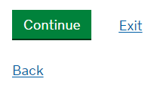
Additional buttons can be added to the toolbar, but it is the form designer’s responsibility to organise the order and layout of the toolbar through form code.
Each section should have a single primary call-to-action button. By default, this will be the Continue button shown above. However, the form designer can create their own primary call-to-action button by doing the following:
- Create a button element by adding a new field, navigating to the Field Data Properties and clicking the button icon in the General tab.
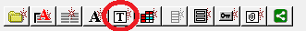
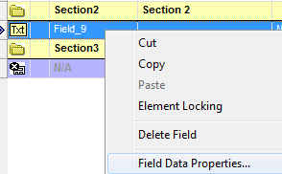
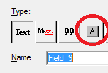
- Change the name of an existing or new button element, ensuring it ends with the suffix __pca.
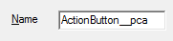
If creating a custom primary call-to-action button, it is recommended that the form designer hides the Continue button using the NavButtonShow command (see the Outreach Code Editor help for more information).
If a custom button does not have the __pca suffix, it will be styled as a secondary action button (or a secondary toolbar action button if Display on Toolbar is selected for the button).
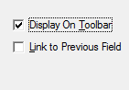

Help Text
By default, fields with help text will have a help icon to the right, which opens a pop-up with the help text when clicked.
In order to utilise GDS-style help, a specific prefix needs to be added to the start of the help text. The available prefixes are as follows:

- Micro text (__micro:) – Available for both standard captions and caption over field.
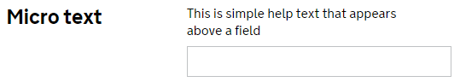
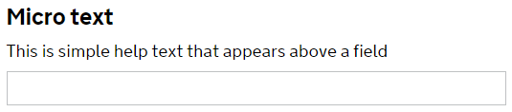

- Help text (__text:) – Available for both standard captions and caption over field.
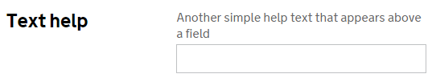
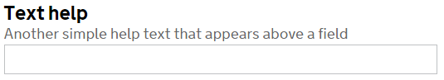

- Indented micro text (__indmicro:) – Available only for captions over field.
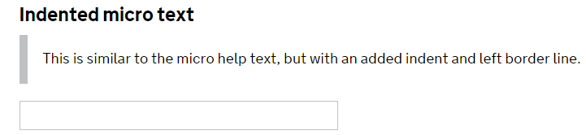

- Captioned dropdown (__drop:) – Available only for captions over field.
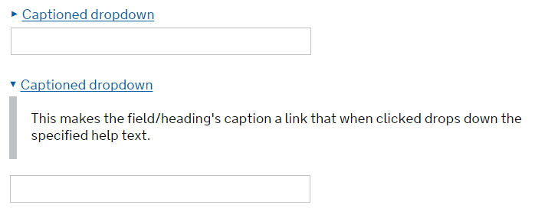

- Help dropdown (__help:) – Available only for captions over field.
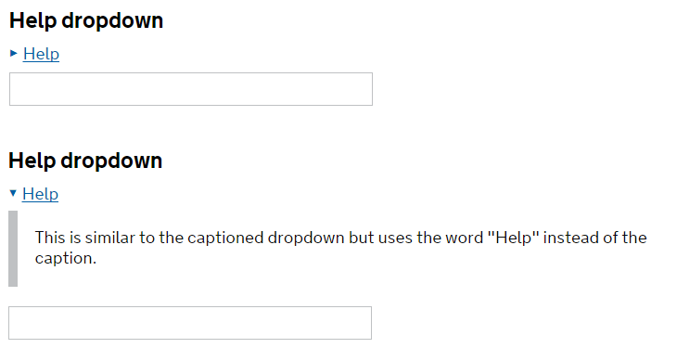
- Guidance text (__guidance:) – Available only for captions over field.
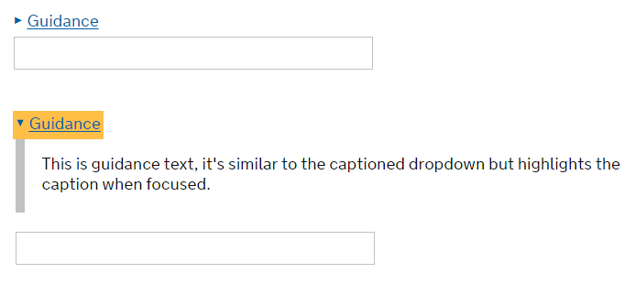
To add GDS-style help to a field, open its Field Data Properties and navigate to the Help and Captions tab. Choose one of the prefixes from above and add it to the beginning of your field’s help text. Note that if you have a field with a Standard Caption Layout and you add a prefix that is not compatible, the help text will not be displayed on the form. If there is no prefix, or Help Is URL is checked, the default Outreach help icon will be used.

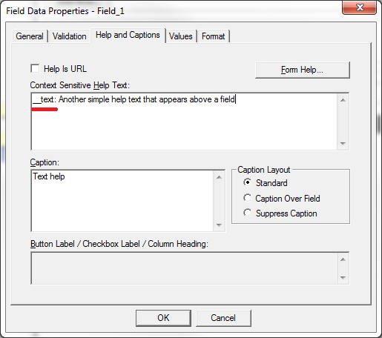

Indented Headings
Some GDS forms require content to stand out using indentation. In order to indent content, add a heading above all the fields and captions you wish to indent.
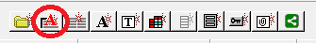
Then modify the name of the heading, ensuring it ends with the suffix __ind.
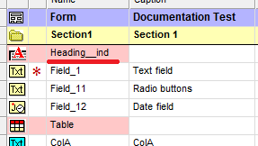
All fields and captions under that heading will now be indented.
